

**1th Balkan International Geography Olympiad**

**Belgrade, Serbia**

**25–29 Jun 2014**

**Written Response Test**

**Resource Booklet**

**Do NOT open the Booklet before instructed to do so by a**

**supervisor.**

**Your answers will NOT be marked if you write them in this Resource Booklet.**

**Section A: Glaciers**

Figure A1: Glacial landform.

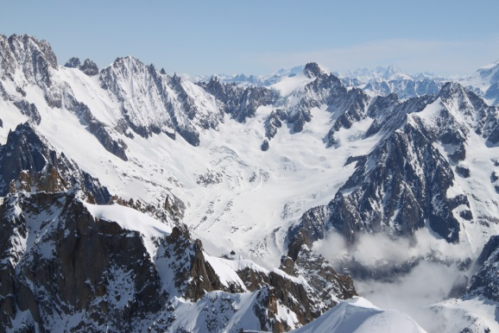

**Section E: Third World urbanization within a global urban system**

Figure E1: A city model.

*source: Fouberg, E.H., Murphy, A.B., & de Blij, H. J. (2009). Human Geography - People, Place, and Culture. John Wiley & Sons, Inc.*

Figure E2: A city model.

*source: Fouberg, E.H., Murphy, A.B., & de Blij, H. J. (2009). Human Geography - People, Place, and Culture. John Wiley & Sons, Inc.*

Figure E3: A city model.

*source: Fouberg, E.H., Murphy, A.B., & de Blij, H. J. (2009). Human Geography - People, Place, and Culture. John Wiley & Sons, Inc.*