Written Response Test

2nd Balkan International Geography Olympiad

Mali Zvornik, Serbia

24th – 30th June, 2016

Do NOT open the Booklet before instructed to do so by a supervisor.

Name:________________________________________________
Team:________________________________________________
Category:_____________________________________________

Instructions for the Students

1. Fill in your name, team and category on the front page.
2. This test consists of 6 Sections.
3. The maximum total mark is 30.
4. The mark for each question is 1.
5. Answer all questions in the spaces provided for every question.
6. Check the backs of pages as questions are printed on both sides of a page.
7. Give only the required number of answers (reasons, examples, etc.) if that is required. For instance, if the question asks for 2 reasons and you give more than 2, only the first 2 reasons will be marked.
8. You may use a calculator during the test as well as bilingual dictionaries.
9. Time: 180 minutes.

Good luck!

- Who is considered the founder of geography, as a science?

- What was the relationship between great geographical discoveries (discovering the new continents in XVI centuries) and the expansion of the Ottoman Empire in Southeast Europe?

- Which are the most important findings of the Second Industrial Revolution (Technological revolution)?

- What is the difference between astronomy and mathematical geography?

5. What causes the change of season on Earth?

- In the years of 2012. India had 1.258.350.971 inhabitants. If the rate of natural increase of population is 12,8 ‰, how many residents India will have in the years of 2020?

- What is density of population? Name few the most densely populated countries in the Europe (not counting dwarf states)?

- What does pseudo – urbanization mean? In which countries and why that process is present?

- What is settlement inversion and why does it occur? Name few countries where it appears.

- Explain the following terms: ecumene, anecumene, and subecumene? Name few areas on the Earth where each of these terms occurs.

- What are the mudflows (torrents) and what are the conditions for their formation?

- What are the physical properties of seawater?

- Why is the Aral Lake (Sea) disappearing?

- In what ways geothermal water can be used?

- What is bifurcation?

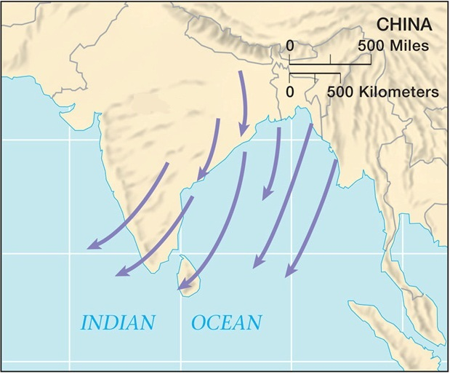
- Which wind is shown in the picture? At what time of the year blows (season)?

- Due to which factors occur and what the weather brings this wind?

- What is the snow line?

- Why the Amazon rainforest is considered as “lungs of the world”?

- In which parts of Africa dominates subtropical climate?

- Describe the term “economic colonialism”.

- Name the French territory in the South America and explain why is so important for France.

- Name the youngest independent country in Asia and the country from which it became independent.

- Where Biafra (country) is located (territory where about million people died from starvation in 1960s)?

- Explain differences between NATO and Warsaw pact.

- Describe the term “Hijrah”.

- In which part of the world do Tuareg people live?

- Name the country in South America where Muslim makes up 20% of population.

- Where does the catholic religion have the most members?

- Name the country where the Pomaks live and their dominant religion.

