BIGEO 3 2017
SOUTHEASTERN EUROPE GEOGRAPHY OLYMPIAD

Fieldwork
test

Suggestions for evaluation

1. River terraces

Task 1
T1
Task 2
In inner part of meander, it can be more. It is accumulation bank.
Task 3
On Figure 2 is seen C is conglomerate (softer material)

2. Influence on the location of the former Ruše Nitrogen Factory.

Task 1
Energy of Fala PS; railway on the important destination; political decision; working power (prisoners); flat area…. + explanation
Task 2:
Located in rural area with low density of population (impact of smoke). Cheaper land. Enough space.
Task3:
The NW wind would spread polluted air to the east.

3. Zip-line (type of cable car)

Task 1 and 2 - calculation:
Distance approx. 400 m. (1 point). Difference 30 m.
30 m / 400 m =0,075 = 7,5 % (1 point)
Task 3
(Depends on calculation) It is possible because it is within limits.

4. Tourism

Task 1
Pohorje
Altitude; exposition; days of snow cover / year; temperature for producing compact (artificial) snow.

Task 2
Jobs, economic development (concrete or specific can be mentioned), better infrastructure, less emigration (outmigration), impacts on population, …
Task 3
Better road connections, more hotel accommodation, advertising, ski tourism activities (ski services, ski rental, ski school ...), support of the local community, applying (international, EU or national) tenders, parking

5. Missing building

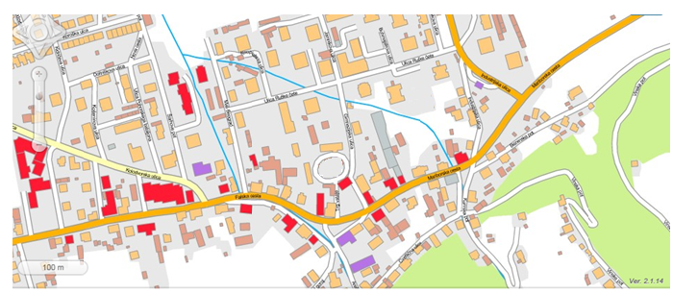
X
X
Legend of the map: missing block and church
X

6. Surplus of buildings

X
X
Legend of the map: surplus
X

Task 3
The direction of the railway line is: Northeast – southwest

7. Town-forming functions (town-forming components) and town-serving activities

Task 1-2:
Factory, railway, political decision, growing population, center of the municipality, schools, shops, … + description
Two = 1 point, Three = 2 points

Task 3
Any of infrastructure + description (3 sentences). Or two services and 1 sentence for each.

8. The role of the railway
Task 1
Local (mostly within Slovenia, only connected with one major town ….)
Regional (mostly Maribor- Prevalje (Panonian – Alpine region, only 81 km (2 hours))
Highway (multicountry SI-AT)

Task 2
Ruše has daily __13 (or 25)__connections with Maribor.
It takes _15 -34_minutes for a train from Ruše to Maribor. (two stations!, +-5 min.)
The average speed of the train between the stations of Ruše and Maribor is __20 - 52_km/h. (according the time in previous answer)

Task 3
Explanation can be subjective/personal, but logical.
Yes because …or not, because ….

- The role of agriculture and forestry

Task 1
For 500-600 km 166-200 hours = 7-9 days.

Task 2
Road, train. Furniture, wooden houses, paper (cellulose) … industry.

Task 3
The land is cultivated but not intensive. Some parts are abandoned. (It depends on opinion of the student)

10. Suburbanization of Ruše

Task 1-3
Must be 2 and logic supported by reasonable arguments. In doubt referring on sources prevail.

11. Essay task for 10 points - Development opportunities of Ruše

Activity | Argument(s) for offering of marked space | Argument(s) for needs of given region | General impression | Suma
1 | 1 | 1 | 1 | 10
1 | 1 | 1
1 | 1 | 1

Remark: Can be modified for 2nd level. Not so strict for 1st level.

